Food Festival Entertainment Application 2025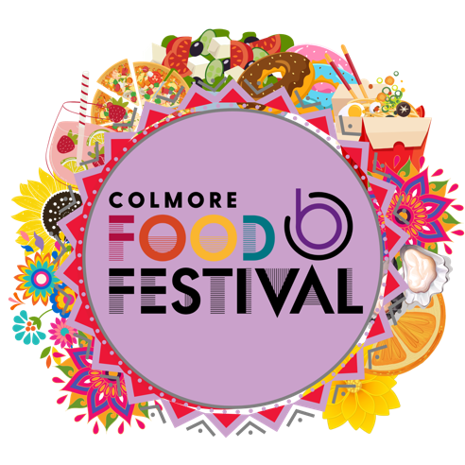

Company Name:

Contact Name:

Contact Email:

Contact Number:

Are you applying to manage entertainment or for a performance slot:

Have you performed at the Colmore Food Festival before? If so, when?

Band size:

Band equipment:

Genre of music:

Social accounts:

Example of work (video or sound):

Cost & Duration per slot:

Cost of entertainment management:

What would you bring to the festival:

